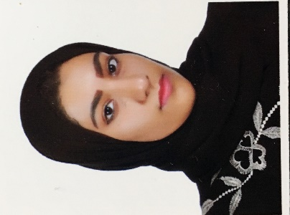

HUDA SALEEM

SITRA, HOUSE 2719, ROAD 344, BLOCK 603

[HSALLEAM@GMAIL.COM](mailto:HSALLEAM@GMAIL.COM)

CPR: 960603972

+973 33302017

+973 39257138

|  |  |  |
| --- | --- | --- |
| Objective | | |
| To be higher experience worker to work with an International company, in more challenging and rewarding roles, to further utilize and develop my skills in commerce/operations. | | |
| Skills | | |
| * Knowledge in computer applications. * Language known: Arabic, English, and little a bit of French & Turkey. * A social person and relationships are created quickly. * Ability work under pressure. * Hard working. * Always on time. * Tendency to work in terms. * Ability to add value to ever field of my work and constantly improve my work methods. * Willing to learn and adapt to new trends in my area of work. | | |
| Relevant Work Experience **From March to** *Working at Private Notary at Bahrain Investor Center – FINANCIAL HARBOUR*  **April 2019** working as :   * + - * Teller, which prepare invoice and receive payment from customer.       * Accountant, prepare financial accounting report.       * Deal with customer and discussed them face to face. .       * Making cash deposit and withdrawal from bank account.       * Do some office work | | |
| Summer 2018 during 5 months |  | TRAINING  *BAPCO- FINANCIAL ACCOUNTING DEPARTMENT*   * Processing invoices to be paid. * Working with Oracl and EMPAC system * Replied to customers and suppliers inquiries. |
| Education 2019 LOMA, professional certificate at TAG TRANING  ALMI, Association life management insurance. | | |
| 2018 |  | Bachelor’s Degree in Banking & Finance  *University of Bahrain , major banking and finance - minor account*  Graduated by University of Bahrain in GPA 3.5 |
| 2010 |  | High school diploma  *Sitra secondary school for girl.* |

|  |  |  |
| --- | --- | --- |
| Activities | | |
| 2018 |  | * Mutamahin- CFA Society Bahrain Feb 2018-May 2018. Intensive soft skills training program designed to create a generation of ethical professional. |